

MSc Computer Science

Name: Ruipeng Jiao

Module: Human Computer Interaction CSC8022

Word count: 518

**REPORT 1:**

**INTRO TO HCI**

**Introduction**

Human-computer interaction (HCI) is research in the design and the use of computer technology, which focuses on the interfaces between people and computers. HCI researchers observe the ways humans interact with computers and design technologies that allow humans to interact with computers in novel ways.

**Multidisciplinary and related technologies**

Because human-computer interaction studies a human and a machine in communication, it draws from supporting knowledge on both the machine and the human side. On the machine side, techniques in computer graphics, operating systems, programming languages, and development environments are relevant. On the human side, communication theory, graphic and industrial design disciplines, linguistics, social sciences, cognitive psychology, social psychology, and human factors such as computer user satisfaction are relevant (figure1). And, of course, engineering and design methods are relevant. (Yvonne, 2012)

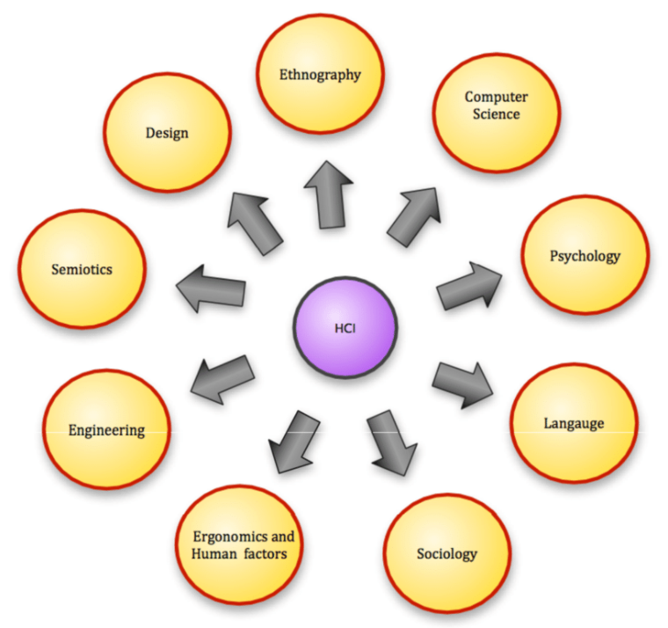

***Figure 1*** *Disciplines in the field of human computer interaction*

Due to the multidisciplinary nature of HCI, people with different backgrounds contribute to its success. Most of the scholars in this section are from psychology, social psychology and sociology, etc.

**Ethics**

HCI is a highly collaborative field involving mathematicians, computer scientists, designers, psychologists and more. In the practical field, HCI is designed by industrialists and politicians. It is also influenced by markets, technological developments and consumer needs. Every level of involvement in the field brings ethical challenges. (Marek, 2014) However, it is worth noting that people cannot place the needs and experiences of users above ethics. Ethics is beginning to play a more important role in HCI. Psychologists believe that HCI is a normative science that aims to improve usability. Traditionally there are three types of normative science: aesthetics, logic, and ethics. Aesthetics deals with the appearance of matters, logic with what is real, and ethics with what is good or bad, or right or wrong. Thus, there is a strong relationship between HCI and ethics.

In addition to ethical aspects, security is equally carefully considered. HCISec is the study of human-computer interaction, particularly in relation to information security. In short, its aim is to improve the usability of security functions in end-user applications. There are a number of reasons when security functions exhibit poor usability, some of which are caused by the following:

·They are added as an afterthought by chance.

·They are patched in a hurry to address a newly discovered security vulnerability.

·They can address very complex use cases without the benefit of software wizards.

·Their interface designers lack an understanding of the relevant security concepts.

·Their interface designers are not usability experts (which usually means they are application developers themselves).

**Methods and principles**

For human-computer interaction design methods have been proposed a lot since the 1980s relied on. (Jonathan,1992) In general, today's models are centred on a steady stream of input and discussion from customers, creators and experts, and combine the framework with the requirements needed by the customer. There are four more established approaches: Activity theory, User-centred design (UCD), Principles of UI design and Value sensitive design (VSD). Other than that the principles of design are considered in terms of Perceptual principles, Mental model principles, Principles based on attention and Memory principles.

**References:**

**·**Grudin, Jonathan (1992). "Utility and usability: research issues and development contexts". Interacting with Computers. **4** (2): 209–217. [doi](https://en.wikipedia.org/wiki/Doi_(identifier)):[10.1016/0953-5438(92)90005-z](https://doi.org/10.1016%2F0953-5438%2892%2990005-z).

**·**Rogers, Yvonne (2012). "HCI Theory: Classical, Modern, and Contemporary". Synthesis Lectures on Human-Centered Informatics. **5** (2): 1–129. [doi](https://en.wikipedia.org/wiki/Doi_(identifier)):10.2200/S00418ED1V01Y201205HCI014.

**·**Friedman, B., Kahn Jr, P. H., Borning, A., & Kahn, P. H. (2006). Value Sensitive Design and information systems. Human–Computer Interaction and Management Information Systems: Foundations. ME Sharpe, New York, 348–372.

**·**Ergoweb. ["What is Cognitive Ergonomics?"](https://web.archive.org/web/20110928150026/http:/www.ergoweb.com/news/detail.cfm?id=352). Ergoweb.com. Archived from [the original](http://www.ergoweb.com/news/detail.cfm?id=352) on September 28, 2011. Retrieved August 29, 2011.

**·**["NRC: Backgrounder on the Three Mile Island Accident"](https://www.nrc.gov/reading-rm/doc-collections/fact-sheets/3mile-isle.html). Nrc.gov. Retrieved August 29, 2011.

**·**["Report of the President's Commission on the Accident at Three Miles Island"](https://web.archive.org/web/20110409064628/http:/www.threemileisland.org/downloads/188.pdf) (PDF). 2019-03-14. Archived from [the original](http://www.threemileisland.org/downloads/188.pdf) (PDF) on 2011-04-09. Retrieved 2011-08-17.

**·**Wickens, Christopher D., John D. Lee, Yili Liu, and Sallie E. Gordon Becker. An Introduction to Human Factors Engineering. Second ed. Upper Saddle River, NJ: Pearson Prentice Hall, 2004. 185–193.

**·**Brown, C. Marlin. Human–Computer Interface Design Guidelines. Intellect Books, 1998. 2–3.

**·**Posard, Marek (2014). "Status processes in human–computer interactions: Does gender matter?". Computers in Human Behavior. **37** (37): 189-195. [doi](https://en.wikipedia.org/wiki/Doi_(identifier)):[10.1016/j.chb.2014.04.025](https://doi.org/10.1016%2Fj.chb.2014.04.025).